Report on

“Good Read's”

SUBMITTED TO

#### Darshan University - Rajkot

IN FULFILLMENT OF THE REQUIREMENTS FOR THE AWARD OF

#### DIPLOMA IN COMPUTER ENGINEERING

SUBMITTED BY

**Student Name Enrollment Number**

Harsh V. Mevada 21020201099

**GUIDED BY**

**Prof. Asha A. Gondaliya**



## March – 2024

#### DEPARTMENT OF COMPUTER ENGINEERING

**DARSHAN INSTITUTE OF ENGG. & TECHNOLOGY FOR DIPLOMA STUDIES RAJKOT-MORBI HIGHWAY, RAJKOT, GUJARAT**

# CERTIFICATE

This is to certify that **Harsh v. Mevada (21020201099)** a student of the Computer Engineering Department from Darshan University - Rajkot, has satisfactorily completed his project work on **“Good Read’s”** in a group consisting of **ONE** person under the guidance of **Prof.Asha A. Gondaliya.**



**Internal Guide**

**(Prof.Asha A. Gondaliya)**

**Head of Department**

**(Prof.Chintan N. Kanani)**

## EXAMINER’S CERTIFICATE OF APPROVAL

This is to certify that project report entitled

**Student Name Enrollment Number**

Harsh V. Mevada 21020201099

In Fulfillment for the award of the diploma in **“Computer Engineering”** of the Darshan University Rajkot is hereby approved.

#### Signature of External Examiner

**Signature of Internal Examiner**



## March – 2024

#### DEPARTMENT OF COMPUTER ENGINEERING

**DARSHAN INSTITUTE OF ENGG. & TECHNOLOGY FOR DIPLOMA STUDIES RAJKOT-MORBI HIGHWAY, RAJKOT, GUJARAT**

## ACKNOWLEDGEMENT

First of all, we thank the almighty for providing us strength and courage to present the project. We avail this opportunity to express our sincere gratitude towards **Prof. Chintan N. Kanani, Head of Computer Engineering Department** for permitting us to conduct the project.

We express our cavernous sense of obligation and gratitude to our Guide **Prof. Asha A. Gondaliya** for her genuine guidance and constant encouragement throughout this project work. We are highly obliged to our honorable guide for providing us with such an opportunity to carry out research work under her continuous guidance.

Also, we are very thankful to Darshan University Computer Department faculties who supported us in getting our website ready. We also wish to express our heartfelt appreciation to our family, colleagues and many who have rendered their support for the successful works towards the completion of the research work, both explicitly and implicitly.

We also thank to our friends who suggested right way for the improvement of our project, they gave us complete support for the construction of our project according to guideline. We deeply acknowledge mutually to all project supporter for their never ending encouragement, moral support and patience during the preparation of this project.

**Student Name Enrollment Number**

Harsh V. Mevada 21020201099

## ABSTRACT

The “Online Good Read’s” is a dynamic website, this website about read quotes there are so many types of quotes and in over website I are doing some different in this website I have add some functionalities to make dynamic website, user can login with their username and password, user can register to the website, user can view title ,content , likes ,comments and author’s name of quotes,user can like the quotes , user can post feedback's , authenticated users can visit website there is the overview of the over project and website.

|  |  |  |
| --- | --- | --- |
|  | **Table of Contents** |  |
| Certificate |  | ii |
| Acknowledgment |  | iv |
| Abstract |  | v |
| Table of Contents |  | vi |
| Index |  | vii |
| List of Figures |  | viii |
| List of Tables |  | ix |

## INDEX

|  |  |  |  |
| --- | --- | --- | --- |
|  |  | | |
| **Chapter No** | **Chapter No** | **Content** | **Page No** |
| 1 |  | **Introduction**…………………………………………... | 1 |
|  | 1.1 | Problem Summary……………………………………... | 1 |
| 2 |  | **Planning**……………………………………………….. | 3 |
|  | 2.1 | Model Description……………………………………... | 3 |
|  | 2.2 | Risk Management……………………………………… | 5 |
| 3 |  | **Detail Description**…………………………………….. | 8 |
| 4 |  | **Diagrams**……………………………………………… | 9 |
|  | 4.1 | Class Diagram…………………………………………. | 9 |
|  | 4.2 | Sequence Diagram……………………………………... | 10 |
|  | 4.3 | Collaboration Diagram………………………………… | 12 |
|  | 4.4 | State Diagram………………………………………….. | 14 |
|  | 4.5 | Activity Diagram………………………………………. | 16 |
|  | 4.6 | Use Case Diagram……………………………………... | 18 |
|  | 4.7 | Data Flow Diagram (Level 0)…………………………. | 19 |
|  | 4.8 | Data Flow Diagram (Level 1)…………………………. | 20 |
| 5 |  | **Data Dictionary**………………………………………. | 22 |
|  | 5.1 | E-R Diagram…………………………………………… | 24 |
| 6 |  | **Screenshots**…………………………………………... | 25 |
| 7 |  | **Conclusion**…………………………………………….. | 41 |
| 8 |  | **Future Enhancement**…………………………………. | 42 |
| 9 |  | **References**…………………………………………… | 43 |

|  |  |  |
| --- | --- | --- |
|  | **List of Figures** |  |
| **Figure No.** | **Description of Figure** | **Page No.** |
| Fig 2.1 | Iterative Waterfall Model |  |
| Fig 4.1 | Class Diagram of Good Read’s | 9 |
| Fig 4.2 | Sequence Diagram for Admin of Good Read’s | 10 |
| Fig 4.2 | Sequence Diagram for User of Good Read’s | 11 |
| Fig 4.3 | Collaboration Diagram for Admin of Good Read’s | 12 |
| Fig 4.3 | Collaboration Diagram for User of Good Read’s | 13 |
| Fig 4.4 | State Diagram for Admin of Good Read’s | 14 |
| Fig 4.4 | State Diagram for User of Good Read’s | 15 |
| Fig 4.5 | Activity Diagram for Admin of Good Read’s | 16 |
| Fig 4.5 | Activity Diagram for User of Good Read’s | 17 |
| Fig 4.6 | Use Case Diagram of Good Read’s | 18 |
| Fig 4.7 | DFD Diagram Level 0 of Good Read’s | 19 |
| Fig 4.8 | DFD Diagram Level 1 for Admin of Good Read’s | 20 |
| Fig 4.8 | DFD Diagram Level 1 for User of Good Read’s | 21 |
| Fig 5.1 | E-R Diagram of Good Read’s | 24 |
| Fig 6.1 | Home Page | 25 |
| Fig 6.2 | Admin Login Page | 26 |
| Fig 6.3 | User Login Page | 27 |
| Fig 6.4 | User Registration Page | 28 |
| Fig 6.5 | Admin Panel Page | 29 |
| Fig 6.6 | Admin Account Page | 30 |
| Fig 6.7 | Admin Add Post Page | 31 |
| Fig 6.8 | Admin Update & delete Post Page | 32 |
| Fig 6.9 | Admin Update profile Page | 33 |
| Fig 6.10 | Post Page | 34 |
| Fig 6.11 | Search Post & Post like & post Comment Page | 35 |
| Fig 6.12 | View Post Page | 36 |
| Fig 6.13 | Post Category Page | 37 |
| Fig 6.14 | Author Page | 38 |
| Fig 6.15 | Admin Logout Page | 39 |
| Fig 6.16 | User Update Profile & Logout Page | 40 |

|  |  |  |
| --- | --- | --- |
|  | **List of Tables** |  |
| **Table No.** | **Description of Tabel** | **Page No.** |
| Table 5.1 | Admin_Master | 22 |
| Table 5.2 | User_Master | 22 |
| Table 5.3 | Like_Master | 22 |
| Table 5.4 | Post_Master | 23 |
| Table 5.5 | Comment_Master | 23 |

## INTRODUCTION

### PROBLEM SUMMRY

#### Problem Identification

In a ticket management system, effectively identifying problems is crucial for efficient issue resolution. To achieve this, the process entails meticulous information gathering and articulation. Firstly, users need to provide a comprehensive description of the problem, including its nature, frequency, and impact. Specific details such as error messages, timestamps, and affected functionalities aid in pinpointing the root cause. Additionally, users should outline any steps they took before encountering the problem, aiding in recreating the issue for troubleshooting. Clear categorization of the problem based on predefined criteria streamlines the allocation to the appropriate support team. Regular updates and collaboration between users and support staff facilitate a deeper understanding of the problem, leading to quicker resolutions. In essence, accurate problem identification hinges on collaborative information exchange, detailed contextualization, and systematic categorization within the ticket management system.

#### Problem Solution

The problem at hand involves enhancing the efficiency of a ticket management system. The current system is facing challenges in terms of effectively managing and resolving user-generated tickets and complaints. The solution entails implementing several key improvements. Firstly, a streamlined user interface will be developed, making it easier for users to submit their issues and provide detailed descriptions. Additionally, an automated categorization system will be integrated to classify incoming tickets accurately, enabling faster routing to the appropriate support teams. Moreover, a comprehensive knowledge base will be established, offering users self-service solutions to common problems, reducing the volume of repetitive tickets. To ensure accountability, automated notifications and escalation processes will be implemented, ensuring that unresolved tickets are promptly escalated to higher levels of support. Finally, robust reporting and analytic tools will be put in place to monitor system performance and identify trends in ticket submissions, allowing for continuous optimization. Overall, this solution aims to transform the ticket management system

## PLANNING

### MODEL DESCRIPTION

Feasibility study

Coding and unit testing

Design

Requirement analysis and specification

Maintenance

Integration and system testing

**Fig 2.1 Iterative Waterfall Model**

* + - In our project we are using iterative waterfall model.
    - It is not possible to strictly follow the classical waterfall model.
    - Making necessary changes to the classical waterfall model so that it becomes applicable to practical software development projects.
    - The main change to the classical waterfall model is in the form of providing feedback paths from every phase to its preceding phases as shown in figure.
    - The feedback paths allow for correction of the errors committed during a phase as and when these are detected in a later phase.
    - For example, if during testing a design error is identified then the feedback path allows the design to be reworked and the changes to be reflected in the design document.
    - There is no feedback path to the feasibility stage. This means that the feasibility study errors cannot be corrected.

#### Requirements analysis and specification

* + - The aim of the requirements analysis and specification phase is to understand the exact requirements of the customer and to document them properly. This phase consists of two distinct activities, namely
      * Requirements gathering and analysis, and
      * Requirements specification
    - The goal of the requirements gathering activity is to collect all relevant information from the customer regarding the product to be developed. This is done to clearly understand the customer requirements so that incompleteness and inconsistencies are removed.
    - The requirements analysis activity is begun by collecting all relevant data regarding the product to be developed from the users of the product and from the customer through interviews and discussions.
    - During SRS activity, the user requirements are systematically organized into a Software Requirements Specification (SRS) document.

#### Design

* + - During the design phase the software architecture is derived from the SRS document. Two distinctly different approaches are available.
    - Traditional design consists of two different activities; first a structured analysis of the requirements specification is carried out where the detailed structure of the problem is examined. During structured design, the results of structured analysis are transformed into the software design.

#### Coding and unit testing (Implementation)

* + - The purpose of the coding and unit testing phase of software development is to translate the software design into source code. Each component of the design is implemented as a program module. The end-product of this phase is a set of program modules that have been individually tested.
    - Each module is unit tested for determine the correct working of all the individual modules.

#### Integration and system testing

* + - Integration of different modules is done once they have been coded and unit tested. During the integration and system testing phase, the modules are integrated in a planned manner.
    - Finally, when all the modules have been successfully integrated and tested, system testing is carried out. The goal of system testing is to ensure that the developed system conforms to its requirements laid out in the SRS document. System testing usually consists of three different kinds of testing activities.
    - α – testing: It is the system testing performed by the development team.
    - β – Testing: It is the system testing performed by a friendly set of customers.
    - Acceptance testing: It is the system testing performed by the customer himself after the product delivery to determine whether to accept or reject the delivered product.

#### Maintenance

* + - Maintenance involves performing any one or more of the following three kinds of activities:
      * Correcting errors that were not discovered during the product development phase. This is called corrective maintenance.
      * Improving the implementation of the system, and enhancing the functionalities of the system according to the customer’s requirements. This is called perfective maintenance.
      * Porting the software to work in a new environment. For example, porting may be required to get the software to work on a new computer platform or with a new operating system. This is called adaptive maintenance.

### Risk Management

* + - The aim of risk management is to reducing the impact of all kind of risks that might affect a project. Risk management consists of three essential activities: risk identification, risk assessment, and risk containment.

#### Risk Identification

* + - A software project can be affected by a large variety of risks. In order to be able to systematically identify the important risks which might affect a software project, it is necessary to categorize risks into different classes.
    - The project manager can then examine which risks from each class are relevant to the project. There are three main categories of risks which can affect a software project: **Project Risks**
      * Project risks concern varies forms of budgetary, schedule, personnel, resource, and customer-related problems. An important project risk is schedule. It is very difficult to monitor and control a software project.
      * It is very difficult to control something which cannot be seen.
      * The invisibility of the product being developed is an important reason for many software projects failure.
      * So in our project we are trying to resolve this kind of project risk which is also known as schedule risk.

#### Technical Risks

* + - * Technical risks concern design, implementation, interfacing, testing, and maintenance problems.
      * Technical risks also include ambiguous specification, incomplete specification, changing specification, technical uncertainty. Most technical risks occur due to the team member’s insufficient knowledge about the project.
      * So in order to prevent this risk, we have done appropriate project analysis before starting our project.

#### Business Risks

* + - * This type of risks include risks of building an excellent product that no one wants, losing budgetary or personnel commitments, etc.

#### Risk Assessment

* + - Risk assessment involves identifying risk, analyzing them and then assigns priority to them on the basis of the analysis.
    - The objective of risk assessment is to rank the risks in terms of their damage. For risk assessment, first each risk should be rated in two ways:
    - The probability of a risk coming true (denoted as r).
    - The result of the problems associated with that risk (denoted as s).
    - Based on these two factors, the priority of each risk can be computed:

#### p = r * s

* + - Where, p is the priority with which the risk must be handled, r is the probability of the risk becoming true, and so is the result of damage caused due to the risk becoming true. If all identified risks are prioritized, then the most likely and damaging risks can be handled first and reject procedures can be designed for these risks.

#### Risk Containment

* + - After all the identified risks of a project are assessed, plans must be made to containment the most damaging and the most likely risks.
    - Different risks require different containment procedures. In fact, most risks require expertness on the part of the project manager in handling the risk.
    - There are three main strategies to plan for risk containment:
      * **Avoid the risk:** This may take several forms such as discussing with the customer to change the requirements to reduce the scope of the work.
      * **Transfer the risk:** This strategy involves getting the risky component developed by a third party.
      * **Risk reduction:** This involves planning ways to containment the damage due to a risk.
    - To choose between the different strategies of handling a risk, the project manager must consider the cost of handling the risk and the corresponding reduction in risk.
    - For this we may compute the risk leverage of the different risks. Risk leverage is the difference in risk divided by the cost of reducing the risk.

#### Risk leverage = (Risk before reducing - Risk after reducing) / cost of reducing

## 3.DETAIL DESCRIPTION

**Admin**

Admin login into the website and Add quotes , edit quotes , update quotes , delete quotes , view quotes like and count quotes like , view comment filled user , than logout from website.

* **Admin_ID**: id of admin.
* **Admin_Name**: name of admin.
* **Admin_Password**: password of admin.

**User**

User Registration of login or login into the website , user will visits website , user will search quotes category , user will select quotes category , user view quotes , user like quotes , user comment quotes or fill comment , user logout from the website.

* **User_ID** : id of user.
* **User_Name**: name of user.
* **User_Email**: Email of user.
* **User_Password**: password of user.

**Like**

User has like the post admin will count like how may liked by user.

* **Like_ID**: id of like.
* **User_ID**: id of user.
* **Post_ID**: id of post.
* **Admin_ID**: id of admin.

**Post**

Post will add by admin , search by user , select by user , update post by admin , delete post by admin , post category select by user , view post by user & admin.

* **Post_ID**: id of post.
* **Admin_ID**: id of admin.
* **Post_Name**: name of post.
* **Image**: image of post.
* **Post_Date**: date of post.
* **Post_Status**: status of post.

**Comment**

User has view post liked and comment post by user fill comment / comment post by user , view comment , count comment.

* **Comment_ID**: id of comment.
* **Post_ID**: id of post.
* **Admin_ID**: id of admin.
* **User_ID**: id of user.
* **Comment**: comment fill of comment.
* **Date**: date of comment.

**4.DIAGRAMS**

## 4.1 Class Diagram

## *Screenshot 2023-12-29 105604*

## Fig 4.1 Class Diagram **of Good Read’s**

**4.2 Sequence Diagram**

***4.2.1 Sequence Diagram for Admin***

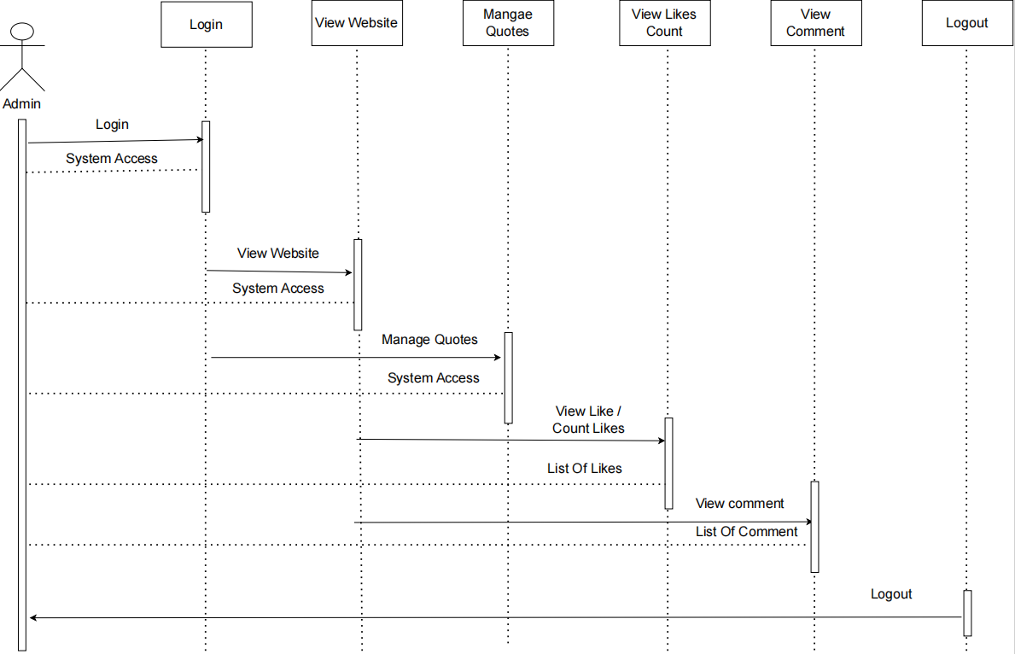

**Fig 4.2.1 Sequence Diagram for Admin Side of Good Read’s**

**4.2 Sequence Diagram**

***4.2.2 Sequence Diagram for User***

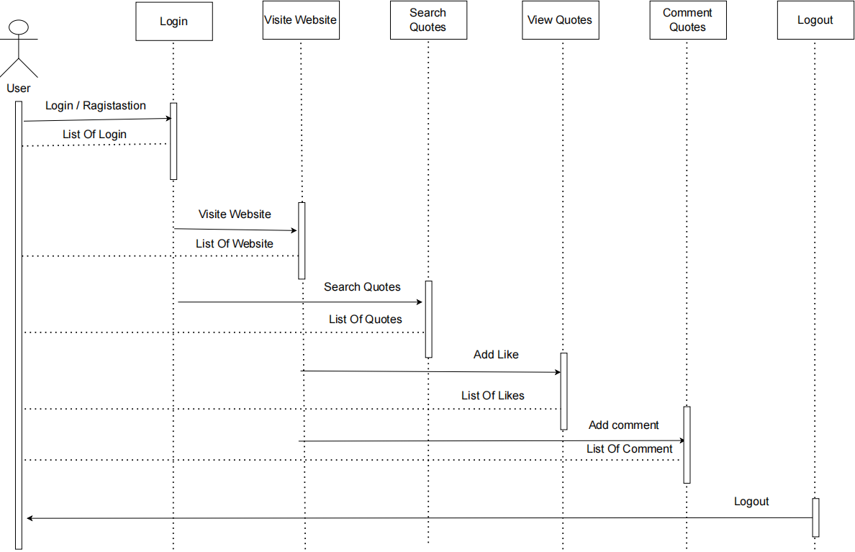

**Fig 4.2.2 Sequence Diagram for User Side of Good Read’s**

**4.3 Collaboration Diagram**

***4.3.1 Collaboration Diagram for Admin***

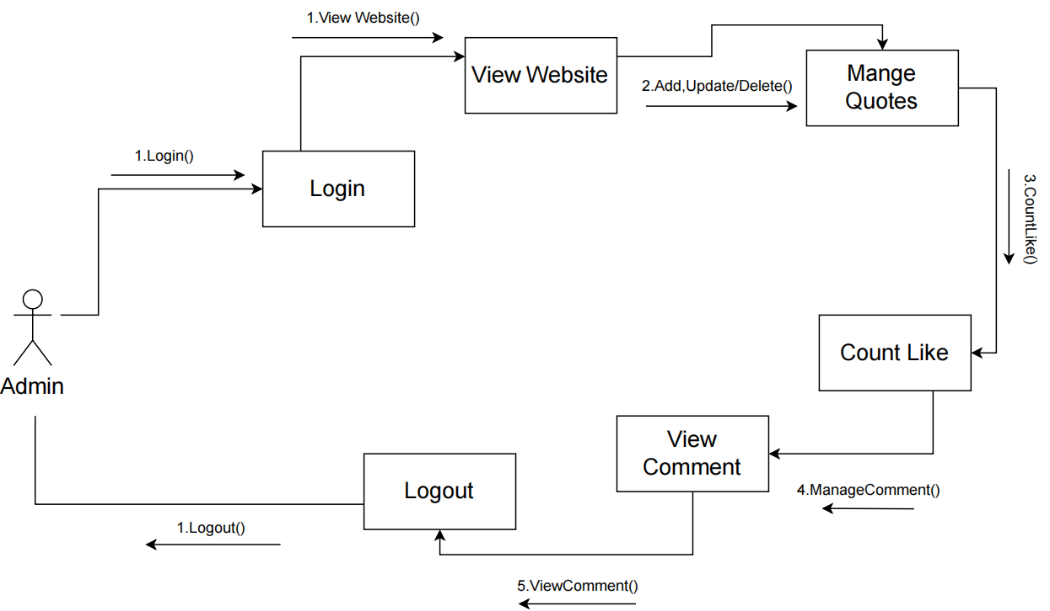

**Fig 4.3.1 Collaboration Diagram for Admin Side of Good Read’s**

**4.3 Collaboration Diagram**

***4.3.2 Collaboration Diagram for User***

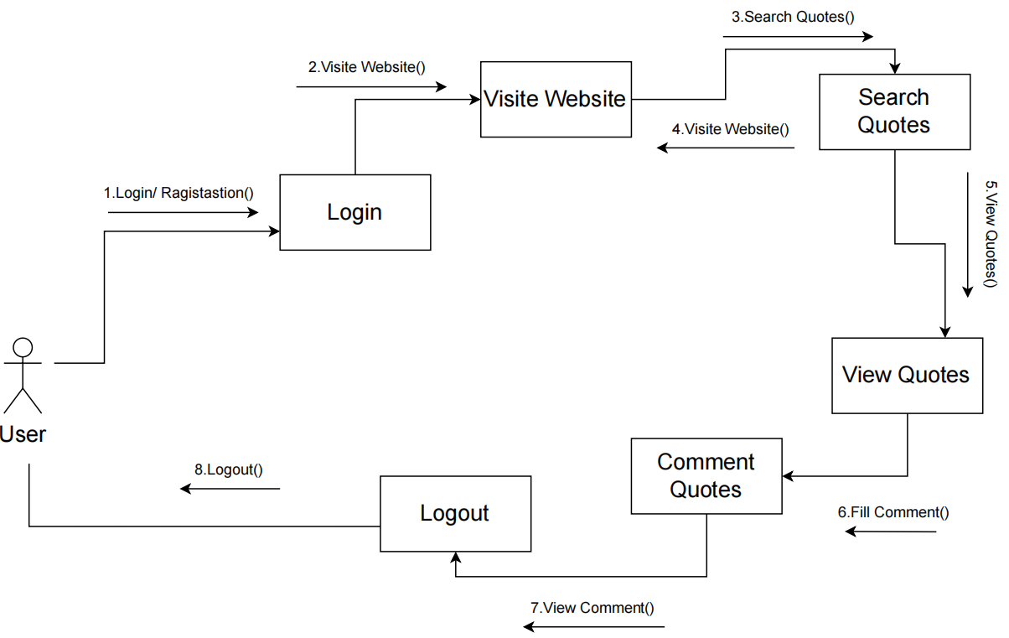

**Fig 4.3.2 Collaboration Diagram for User Side of Good Read’s**

**4.4 State Diagram**

***4.4.1 State Diagram for Admin***

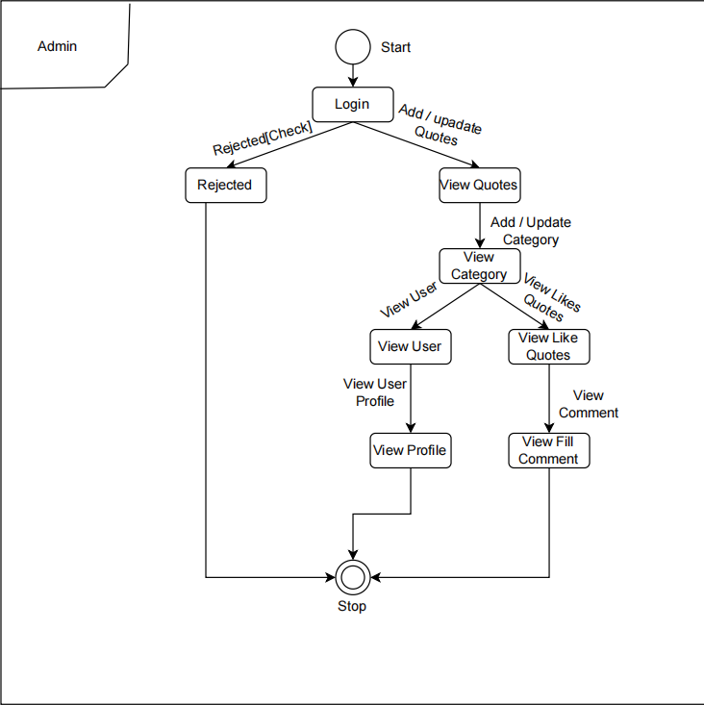

**Fig 4.4.1 State Diagram for Admin Side of Good Read’s**

**4.4 State Diagram**

***4.4.2 State Diagram for User***

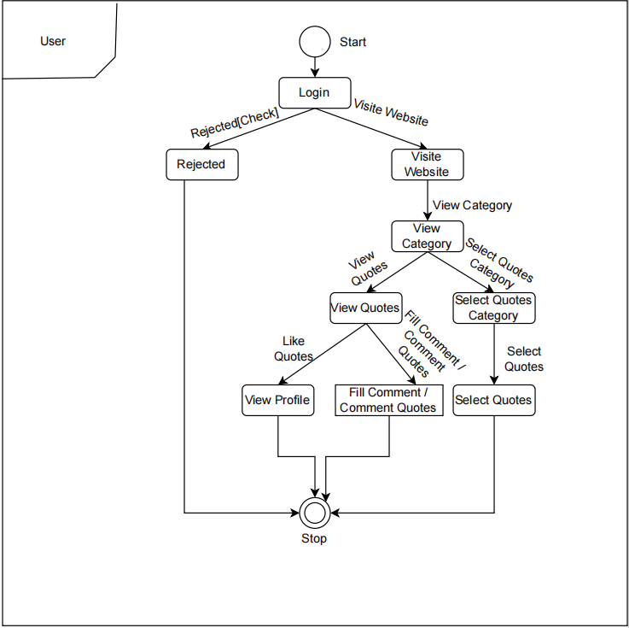

**Fig 4.4.2 State Diagram for User Side of Good Read’s**

**4.5 Activity Diagram**

***4.5.1 Activity Diagram for Admin***

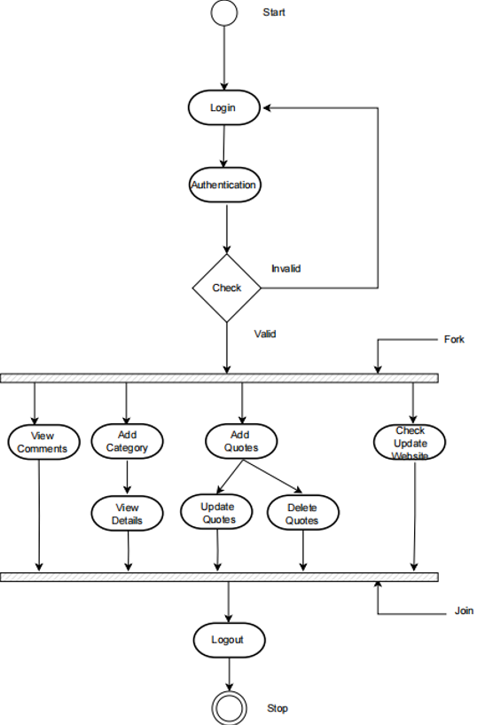

**Fig 4.5.1 Activity Diagram for Admin Side of Good Read’s**

**4.5 Activity Diagram**

***4.5.2 Activity Diagram for User***

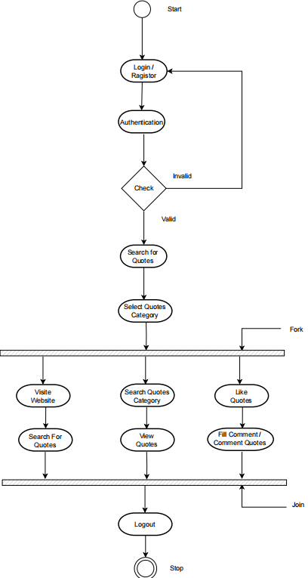

**Fig 4.5.2 Activity Diagram for User Side of Good Read’s**

**4.6 Use Case Diagram**

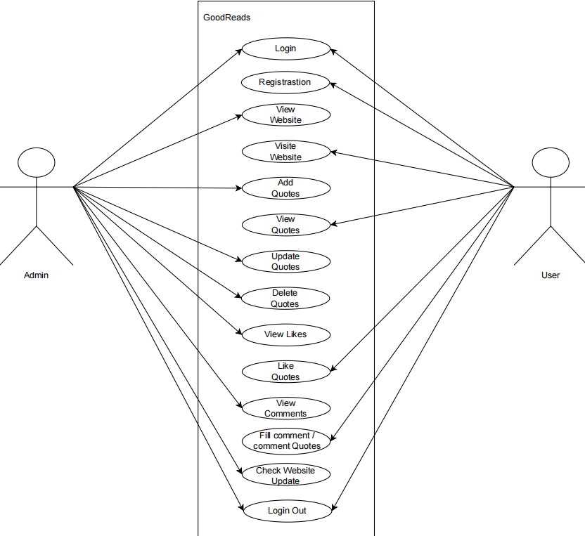

**Fig 4.6 Use Case Diagram for Good Read’s**

**4.7 Data Flow Diagram**

***4.7.1 Data Flow Diagram Level 0***

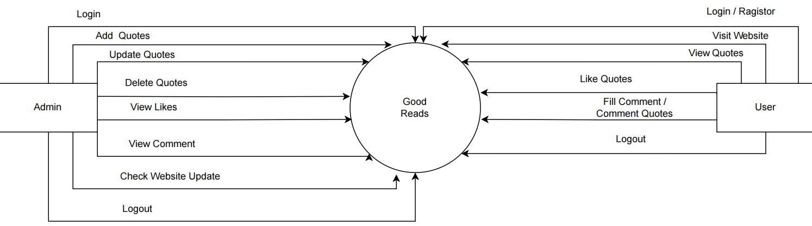

**Fig 4.7.1 Date Flow Diagram Level 0 of Good Read’s**

**4.8 Data Flow Diagram Level 1**

***4.8.1 Date Flow Diagram Level 1 for Admin***

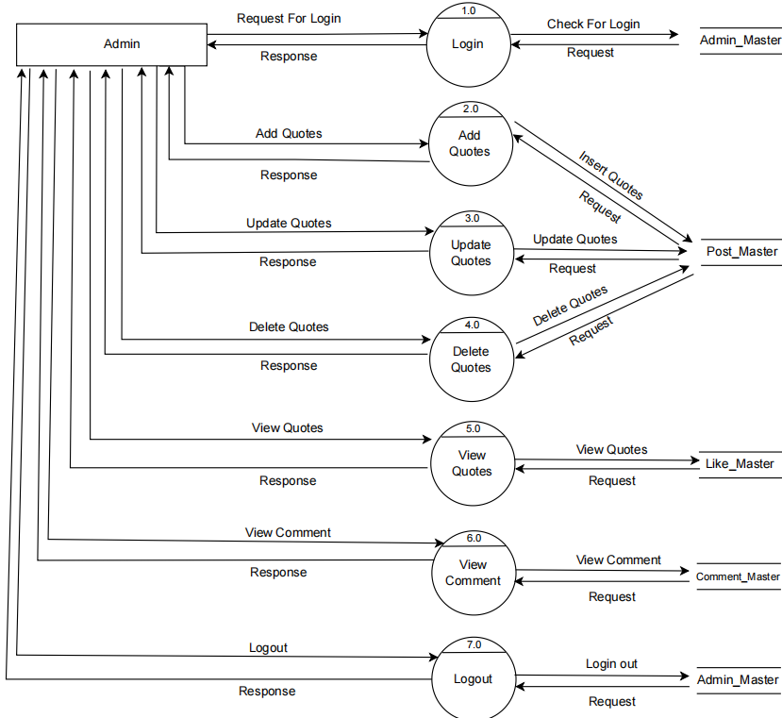

**Fig 4.8.1 Data Flow Diagram Level 1 for Admin Side of Good Read’s**

**4.8 Data Flow Diagram Level 1**

***4.8.2 Data Flow Diagram Level 1 for User***

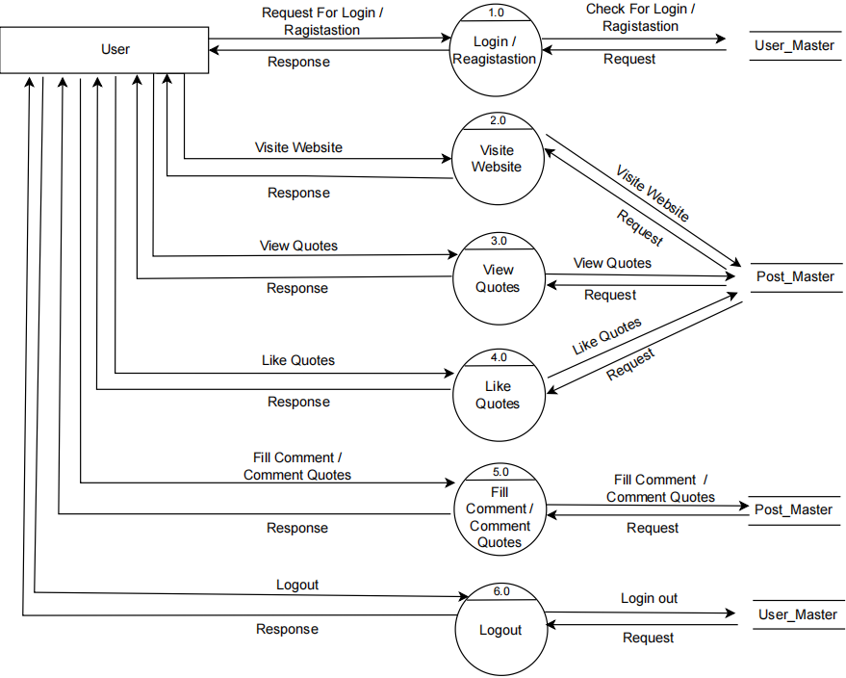

**Fig 4.8.2 Data Flow Diagram Level 1 for User Side of Good Read’s**

## 5.DATA DICTIONARY

### 5.1 DATABASE TABLES

#### *Table 5.1 : Admin_Master*

|  |  |  |  |  |  |
| --- | --- | --- | --- | --- | --- |
| **Admin_Master** | | | | | |
| **Field_Name** | **Data_Type** | **Size** | **Constraint** | **Reference** | **Description** |
| Admin_ID | INT | 10 | PRIMARY KEY | - | It Describes Admin ID |
| Admin_Name | VARCHAR | 50 | NOT NULL | - | It Describes Admin Name |
| Admin_Password | VARCHAR | 50 | NOT NULL | - | It Describes Admin Password |

***Table 5.2 : User_Master***

|  |  |  |  |  |  |
| --- | --- | --- | --- | --- | --- |
| **User_Master** | | | | | |
| **Field_Name** | **Date_Type** | **Size** | **Constant** | **Reference** | **Description** |
| User_ID | INT | 10 | PRIMARY KEY | - | It Describes User ID |
| User_Name | VARCHAR | 50 | NOT NULL | - | It Describes User Name |
| User_Email | VARCHAR | 50 | NOT NULL | - | It Describes User Email |
| User_Password | VARCHAR | 50 | NOT NULL | - | It Describes User Password |

#### *Table 5.3 : Like_Master*

|  |  |  |  |  |  |
| --- | --- | --- | --- | --- | --- |
| **Liker_Master** | | | | | |
| **Field_Name** | **Data_Type** | **Size** | **Constant** | **Reference** | **Description** |
| Like_ID | INT | 10 | PRIMARY KEY | - | It Describes Like ID |
| User_ID | INT | 10 | FOREIGN KEY | User_Master | It Describes User ID |
| Post_ID | INT | 10 | FOREIGN KEY | Post_Master | It Describes Post ID |
| Admin_ID | INT | 10 | FOREIGN KEY | Admin_Master | It Describes Admin Id |

***Table 5.4 : Post_Master***

|  |  |  |  |  |  |
| --- | --- | --- | --- | --- | --- |
| **Post_Master** | | | | | |
| **Field_Name** | **Date_Type** | **Size** | **Constant** | **Reference** | **Description** |
| Post_ID | INT | 10 | PRIMARY KEY | - | It Describes Post ID |
| Admin_ID | INT | 10 | FOREIGN KEY | Admin_Master | It Describes Admin ID |
| Post_Name | VARCHAR | 50 | NOT NULL | - | It Describes Post Name |
| Post_Content | VARCHAR | 50 | NOT NULL | - | It Describes Post Content |
| Post_Category | VARCHAR | 50 | NOT NULL | - | It Describes Post Category |
| Image | IMAGE | - | NOT NULL | - | It Describes Post Image |
| Post_Date | DATE | 10 | NOT NULL | - | It Describes Post Date |
| Post_Status | VARCHAR | 50 | NOT NULL | - | It Describes Post Status |

***Table 5.5 : Comment_Master***

|  |  |  |  |  |  |
| --- | --- | --- | --- | --- | --- |
| **Comment_Master** | | | | | |
| **Field_Name** | **Date_Type** | **Size** | **Constant** | **Reference** | **Description** |
| Comment_ID | INT | 10 | PRIMARY KEY | - | It Describes Comment ID |
| Post_ID | INT | 10 | FOREIGN KEY | Post_Master | It Describes Post ID |
| Admin_ID | INT | 10 | FOREIGN KEY | Admin_Master | It Describes Admin ID |
| User_ID | INT | 10 | FOREIGN KEY | User_Master | It Describes User ID |
| User_Name | INT | 10 | FOREIGN KEY | User_Master | It Describes User Name |
| Comment | VARCHAR | 50 | NOT NULL | - | It Describes Comment |
| Date | DATE | 10 | NOT NULL | - | It Describes Date |

**5.1 E-R Diagram**

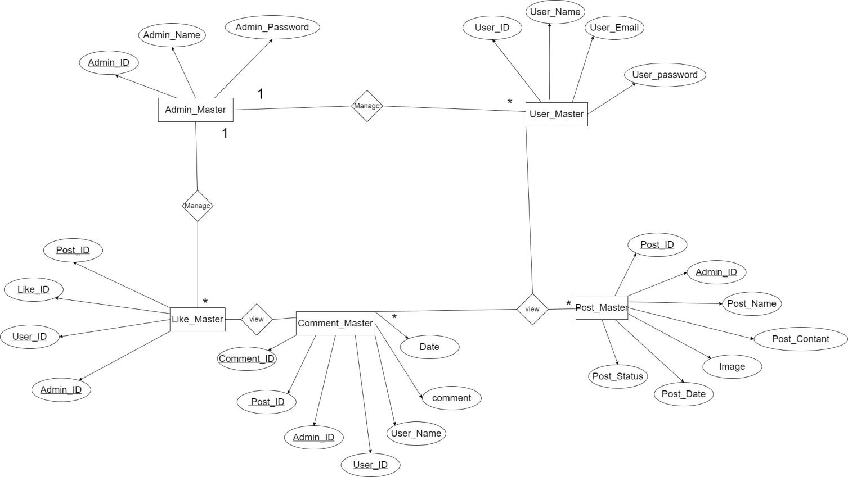

**Fig 5.1 E-R Diagram of Good Read’s**

**6.Screen Short**

**Home Page**

Good Read’s

**Fig 6.1 Home Page**

* User Will Visit Website.
* Admin Will View Website.
* This is the website of blog & (Good Read’s).

**Admin Login**

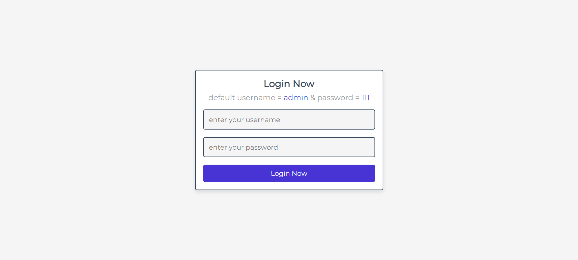

**Fig 6.2 Admin Login Page**

* Admin Will Login into Website.
* Admin Will Open Admin Panel Website.
* This is the website of Admin Login.

**User Login Page**

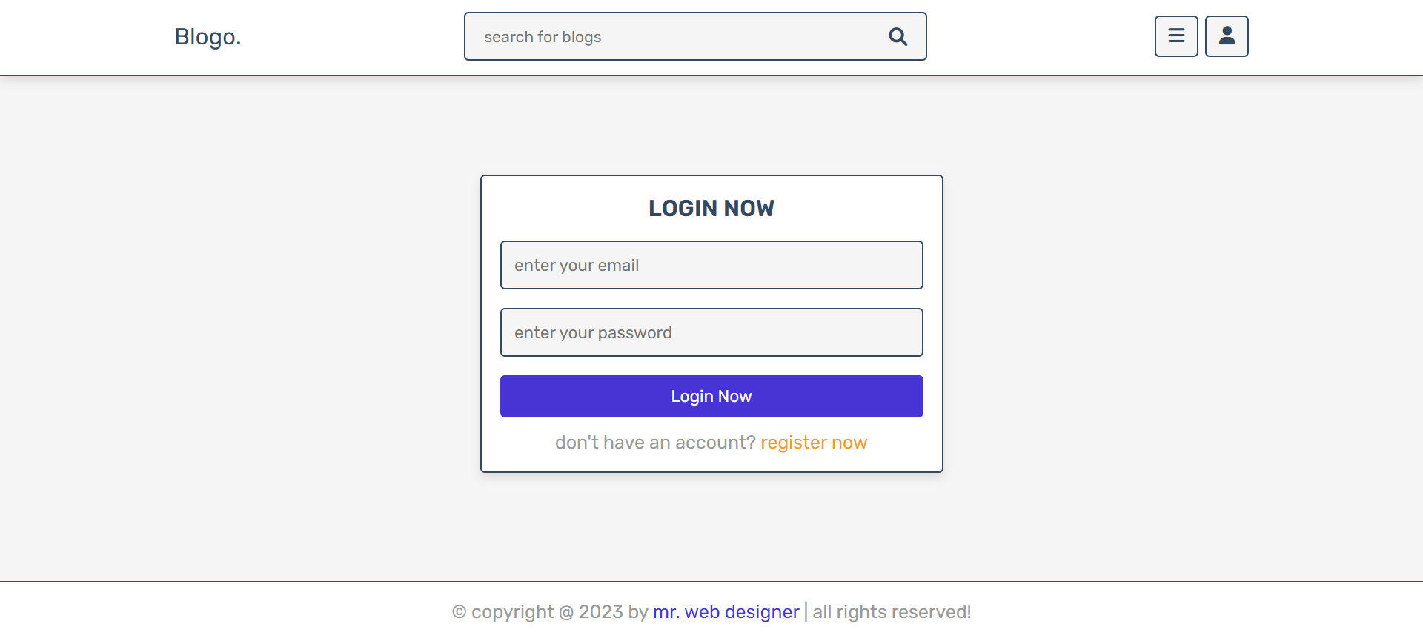

Good Read’s

**Fig 6.3 User Login Page**

* User Will Login into the Website.
* User Will View Website.
* This is the website of Login.

**User Registration**

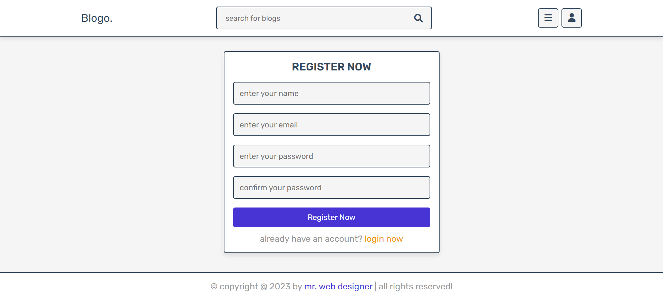

Good Read’s

**Fig 6.4 User Registration Page**

* User Will Registration into the Website.
* User Will View Website.
* This is the website of Registration.

**Admin dashbord**

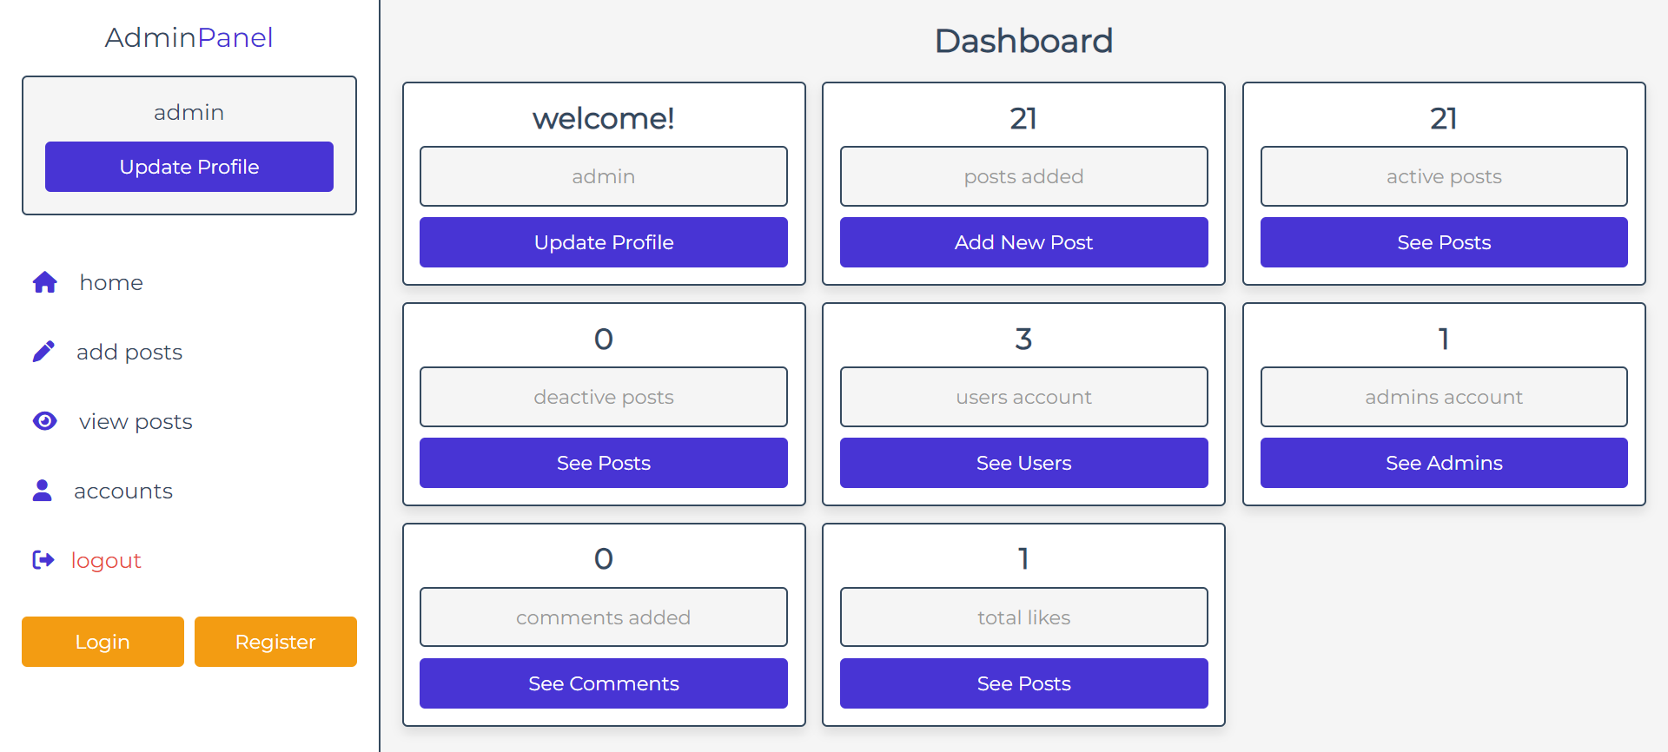

**Fig 6.5 Admin Panel Page**

* Admin Will Open Panel .
* Admin Will View Website.
* This is the website of Admin Panel.

**Admin Account Page**

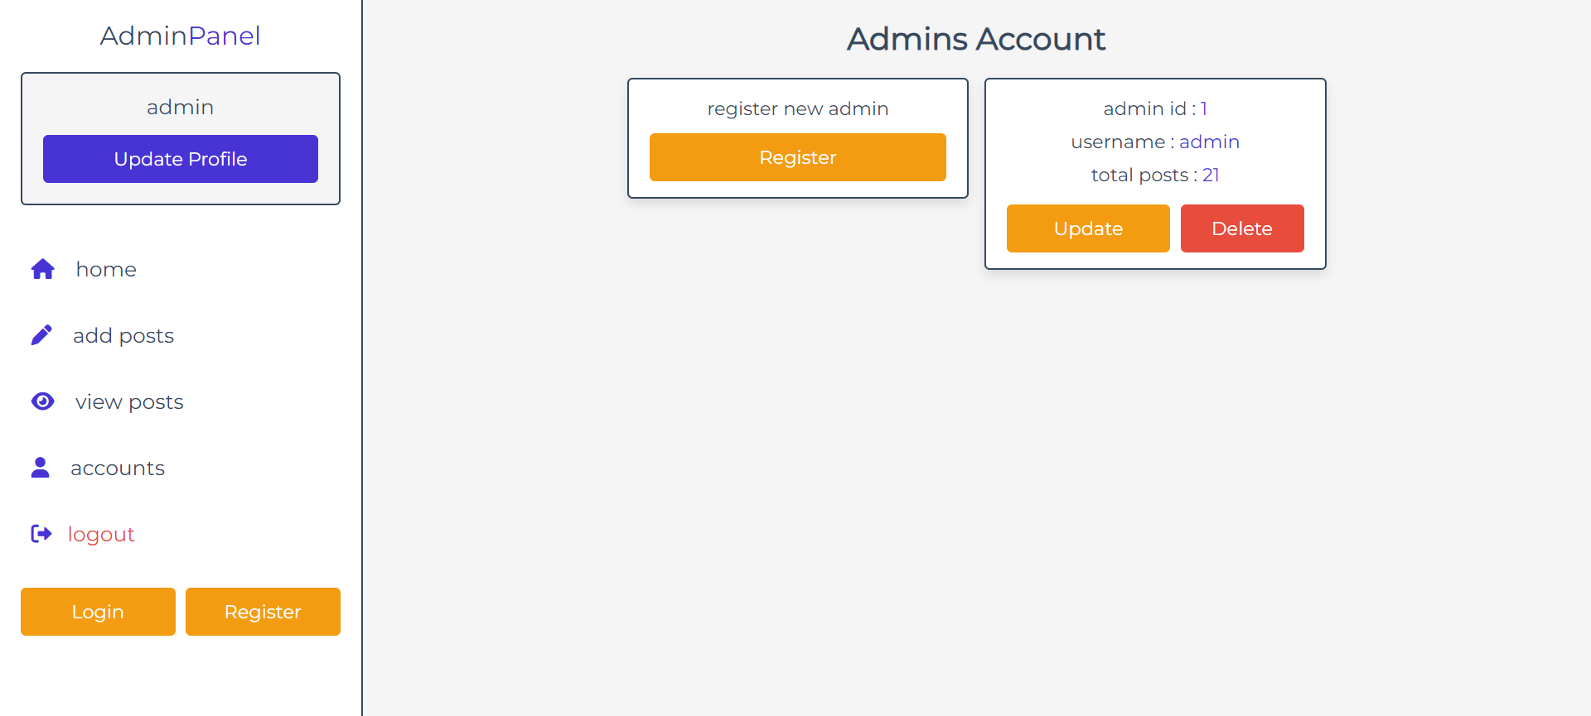

**Fig 6.6 Admin Account Page**

* Admin Will Open Panel .
* Admin Will Open Her Account Page.
* This is the website of Admin Account Page.

**Admin add post page**

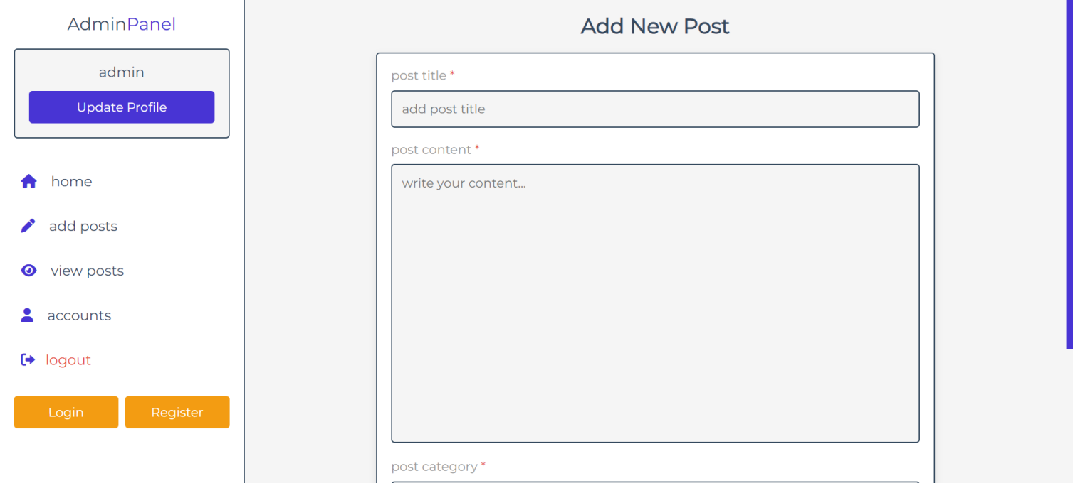

**Fig 6.7 Admin add post Page**

* Admin Will Open Panel .
* Admin Will Add Quotes.
* This is the website of Admin Add Quotes Page.

**Admin update & delete post page**

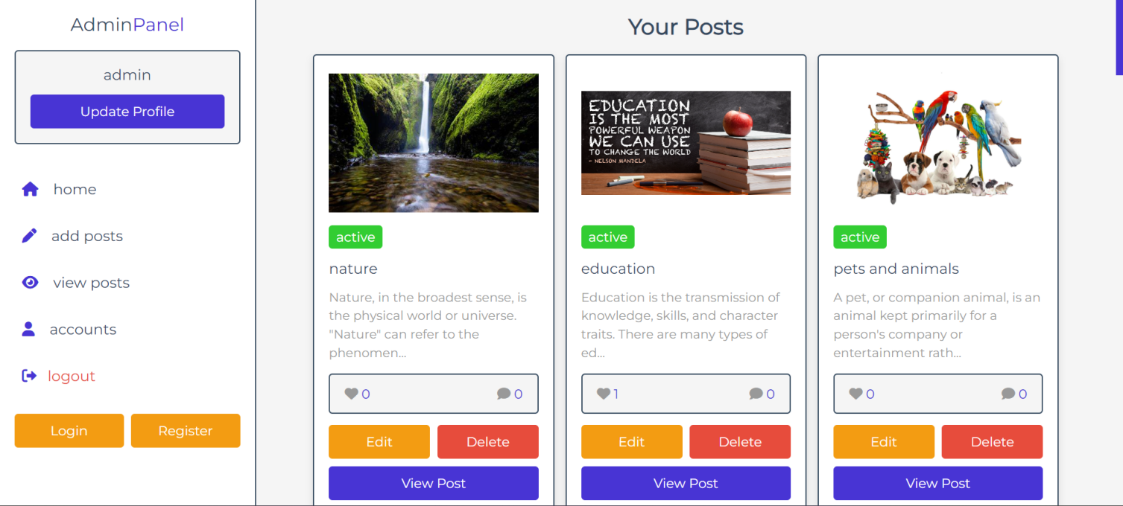

**Fig 6.8 Admin update & delete post Page**

* Admin Will Open Panel .
* Admin Will Update or Delete Quotes.
* This is the website of Admin Update or Delete Quotes Page.

**Admin update profile**

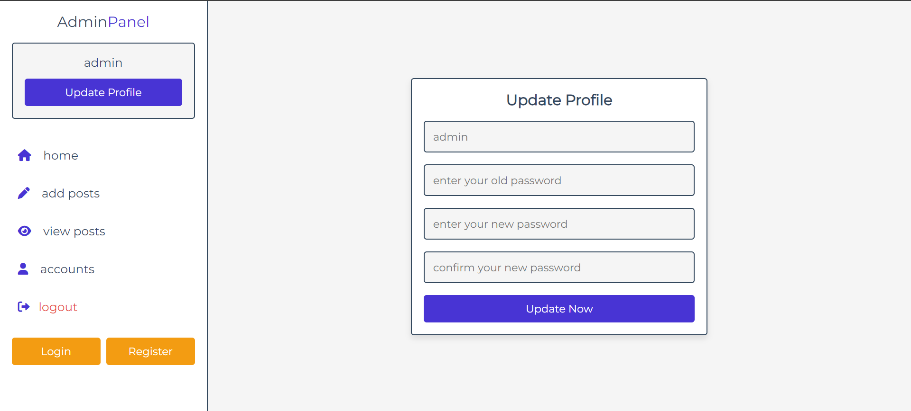

**Fig 6.9 Admin update profile Page**

* Admin Will Open Panel .
* Admin Will Update Her Profile.
* This is the website of Admin Profile Page.

**Post page**

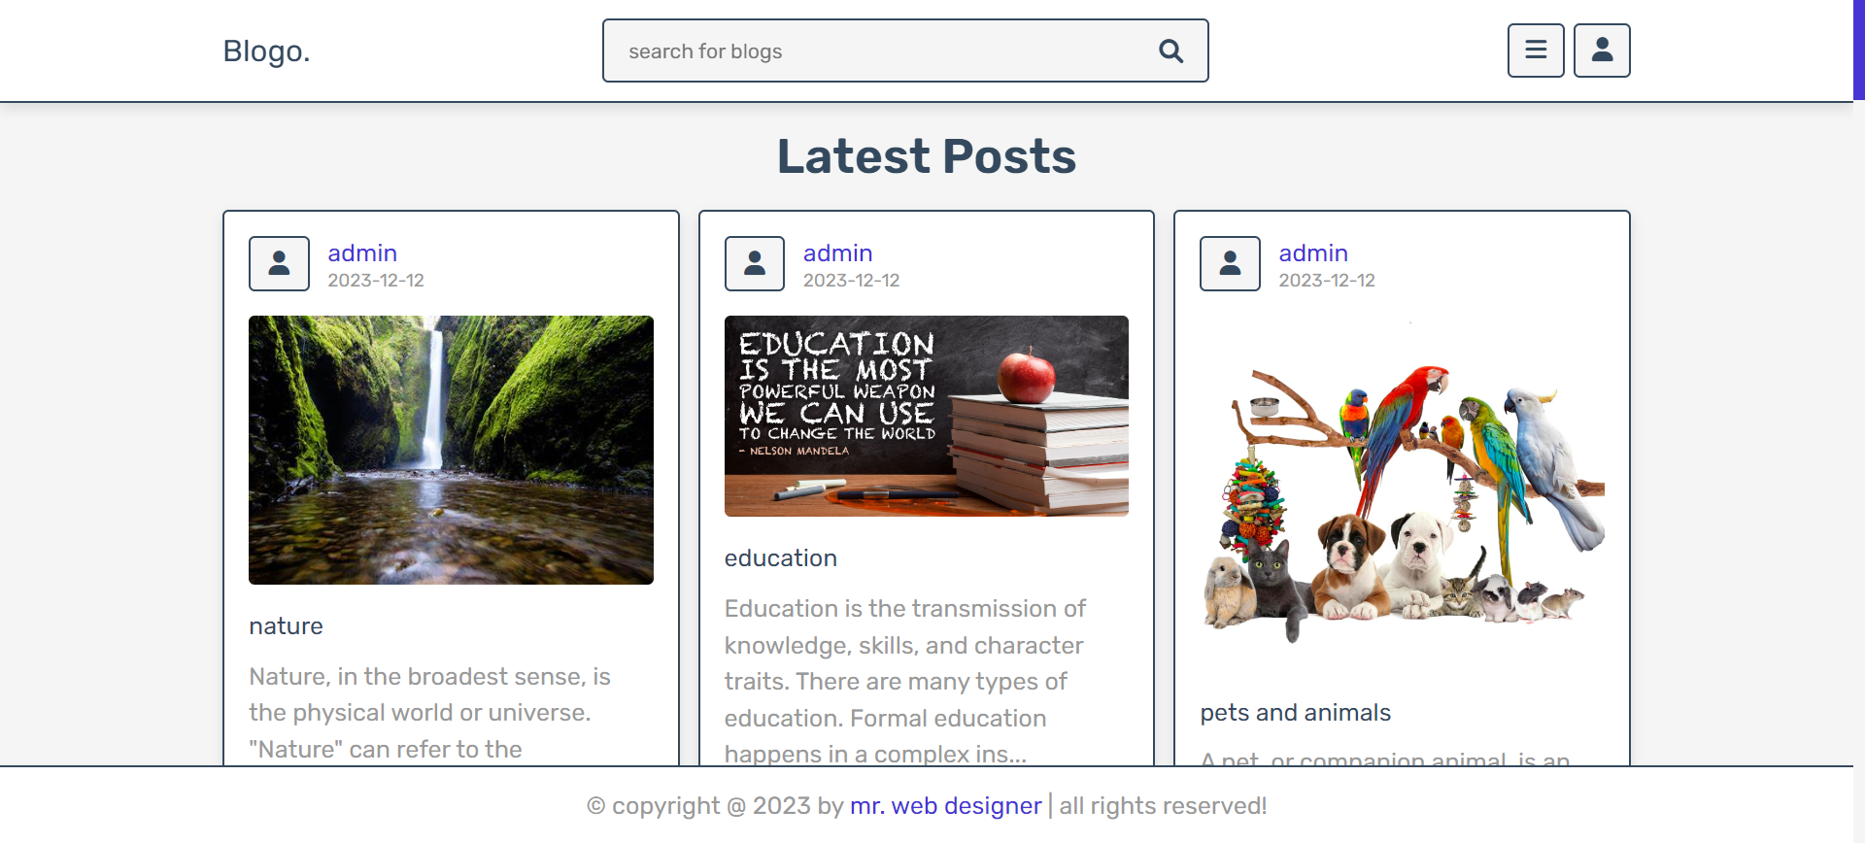

Good Read’s

**Fig 6.10 Post Page**

* User Will Open Website .
* User Will View Post.
* This is the website of User Post Page.

**Search post & post like & post comment**

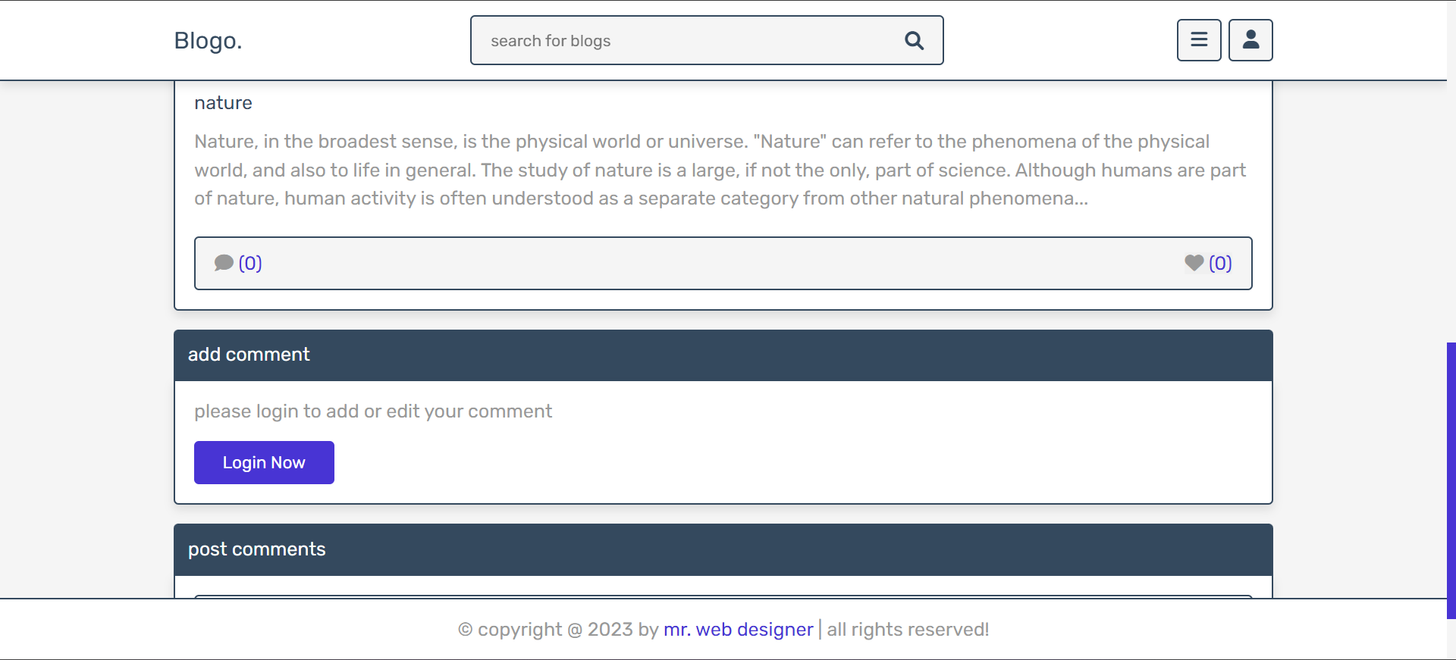

Good Read’s

**Fig 6.11 Search post & post like & post comment**

* User Will Search Quotes .
* User Will Like or Comment Post.
* This is the website of User Search Post & Post Like & Post Comment Page.

**View Post Page**



Good Read’s

**Fig 6.12 View Post Page**

* User Will Open Website.
* User Will Select Random Post.
* This is the website of User View Post Page.

**Post category page**

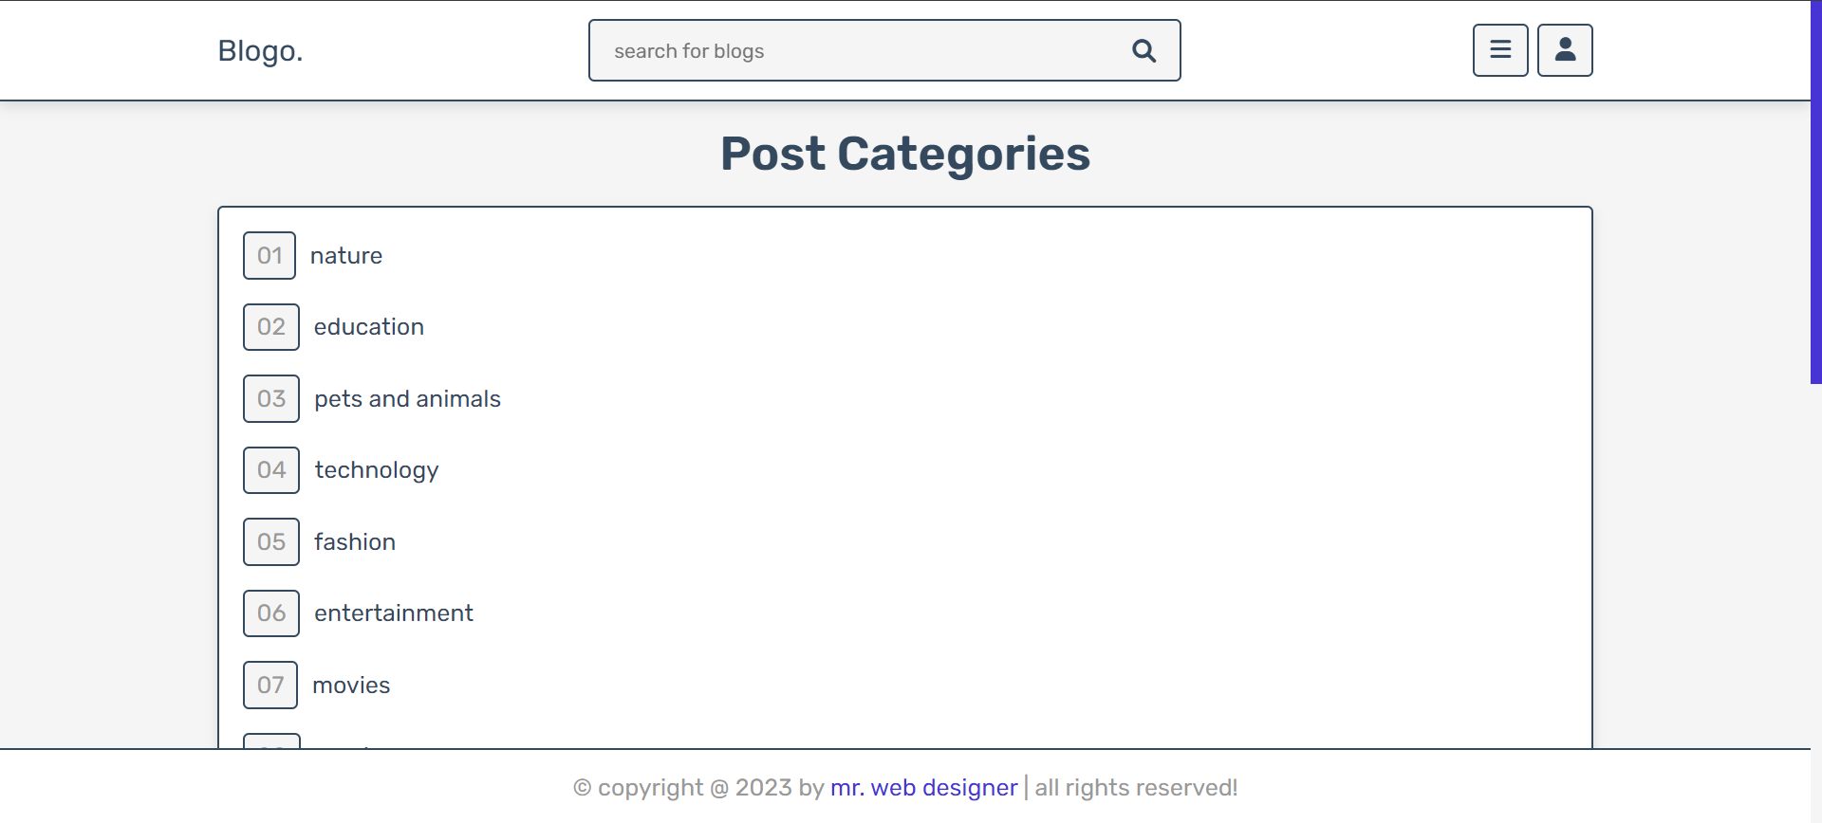

Good Read’s

%3CmxGraphModel%3E%3Croot%3E%3CmxCell%20id%3D%220%22%2F%3E%3CmxCell%20id%3D%221%22%20parent%3D%220%22%2F%3E%3CmxCell%20id%3D%222%22%20value%3D%22%22%20style%3D%22endArrow%3Dnone%3Bhtml%3D1%3Brounded%3D0%3BentryX%3D0.5%3BentryY%3D1%3BentryDx%3D0%3BentryDy%3D0%3BexitX%3D0.5%3BexitY%3D0%3BexitDx%3D0%3BexitDy%3D0%3B%22%20edge%3D%221%22%20parent%3D%221%22%3E%3CmxGeometry%20width%3D%2250%22%20height%3D%2250%22%20relative%3D%221%22%20as%3D%22geometry%22%3E%3CmxPoint%20x%3D%22-151%22%20y%3D%22463%22%20as%3D%22sourcePoint%22%2F%3E%3CmxPoint%20x%3D%22-47.5%22%20y%3D%22240%22%20as%3D%22targetPoint%22%2F%3E%3C%2FmxGeometry%3E%3C%2FmxCell%3E%3C%2Froot%3E%3C%2FmxGraphModel%3E **Fig 6.13 Post Category Page**

* Use Will Open Quotes Category.
* User Will Select Random Category of Quotes.
* This is the website of User Select Post Category Page.

**Author page**

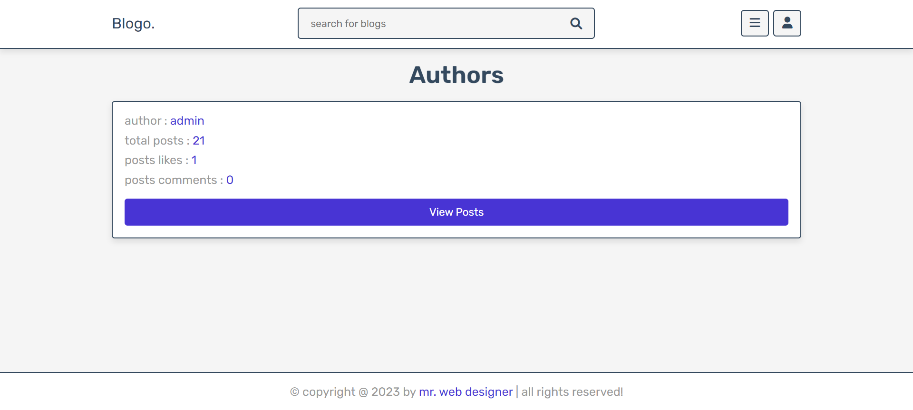

Good Read’s

%3CmxGraphModel%3E%3Croot%3E%3CmxCell%20id%3D%220%22%2F%3E%3CmxCell%20id%3D%221%22%20parent%3D%220%22%2F%3E%3CmxCell%20id%3D%222%22%20value%3D%22%26lt%3Bfont%20style%3D%26quot%3Bfont-size%3A%2036px%3B%26quot%3B%26gt%3B*%26lt%3B%2Ffont%26gt%3B%22%20style%3D%22text%3Bhtml%3D1%3BstrokeColor%3Dnone%3BfillColor%3Dnone%3Balign%3Dcenter%3BverticalAlign%3Dmiddle%3BwhiteSpace%3Dwrap%3Brounded%3D0%3B%22%20vertex%3D%221%22%20parent%3D%221%22%3E%3CmxGeometry%20x%3D%22960%22%20y%3D%22389%22%20width%3D%2260%22%20height%3D%2230%22%20as%3D%22geometry%22%2F%3E%3C%2FmxCell%3E%3C%2Froot%3E%3C%2FmxGraphModel%3E%3CmxGraphModel%3E%3Croot%3E%3CmxCell%20id%3D%220%22%2F%3E%3CmxCell%20id%3D%221%22%20parent%3D%220%22%2F%3E%3CmxCell%20id%3D%222%22%20value%3D%22%22%20style%3D%22endArrow%3Dnone%3Bhtml%3D1%3Brounded%3D0%3BentryX%3D0.5%3BentryY%3D1%3BentryDx%3D0%3BentryDy%3D0%3BexitX%3D0.5%3BexitY%3D0%3BexitDx%3D0%3BexitDy%3D0%3B%22%20edge%3D%221%22%20parent%3D%221%22%3E%3CmxGeometry%20width%3D%2250%22%20height%3D%2250%22%20relative%3D%221%22%20as%3D%22geometry%22%3E%3CmxPoint%20x%3D%22-151%22%20y%3D%22463%22%20as%3D%22sourcePoint%22%2F%3E%3CmxPoint%20x%3D%22-47.5%22%20y%3D%22240%22%20as%3D%22targetPoint%22%2F%3E%3C%2FmxGeometry%3E%3C%2FmxCell%3E%3C%2Froot%3E%3C%2FmxGraphModel%3E **Fig 6.14 Author Page**

* User Will Open Author Page .
* User Will View Who is the Author .
* This is the website of User will View Author Page.

**Admin logout page**

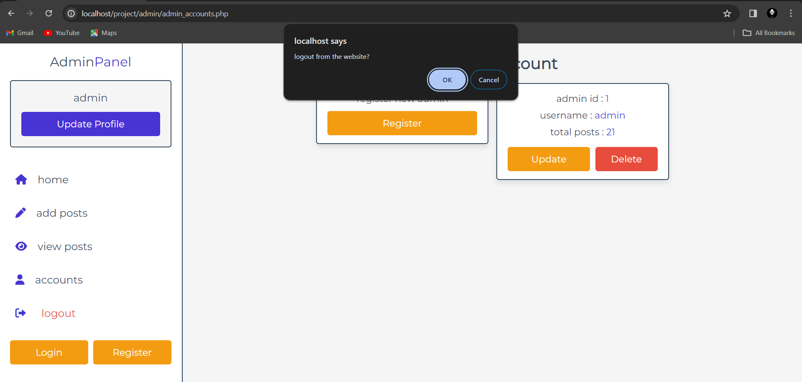

%3CmxGraphModel%3E%3Croot%3E%3CmxCell%20id%3D%220%22%2F%3E%3CmxCell%20id%3D%221%22%20parent%3D%220%22%2F%3E%3CmxCell%20id%3D%222%22%20value%3D%22%26lt%3Bfont%20style%3D%26quot%3Bfont-size%3A%2036px%3B%26quot%3B%26gt%3B*%26lt%3B%2Ffont%26gt%3B%22%20style%3D%22text%3Bhtml%3D1%3BstrokeColor%3Dnone%3BfillColor%3Dnone%3Balign%3Dcenter%3BverticalAlign%3Dmiddle%3BwhiteSpace%3Dwrap%3Brounded%3D0%3B%22%20vertex%3D%221%22%20parent%3D%221%22%3E%3CmxGeometry%20x%3D%22960%22%20y%3D%22389%22%20width%3D%2260%22%20height%3D%2230%22%20as%3D%22geometry%22%2F%3E%3C%2FmxCell%3E%3C%2Froot%3E%3C%2FmxGraphModel%3E%3CmxGraphModel%3E%3Croot%3E%3CmxCell%20id%3D%220%22%2F%3E%3CmxCell%20id%3D%221%22%20parent%3D%220%22%2F%3E%3CmxCell%20id%3D%222%22%20value%3D%22%22%20style%3D%22endArrow%3Dnone%3Bhtml%3D1%3Brounded%3D0%3BentryX%3D0.5%3BentryY%3D1%3BentryDx%3D0%3BentryDy%3D0%3BexitX%3D0.5%3BexitY%3D0%3BexitDx%3D0%3BexitDy%3D0%3B%22%20edge%3D%221%22%20parent%3D%221%22%3E%3CmxGeometry%20width%3D%2250%22%20height%3D%2250%22%20relative%3D%221%22%20as%3D%22geometry%22%3E%3CmxPoint%20x%3D%22-151%22%20y%3D%22463%22%20as%3D%22sourcePoint%22%2F%3E%3CmxPoint%20x%3D%22-47.5%22%20y%3D%22240%22%20as%3D%22targetPoint%22%2F%3E%3C%2FmxGeometry%3E%3C%2FmxCell%3E%3C%2Froot%3E%3C%2FmxGraphModel%3E **Fig 6.15 Admin logout Page**

* Admin Will Logout From the website .
* Admin has completed her Admin will Logout from the Website .
* This is the website of Admin Logout Page.

**User update profile & Logout Page**

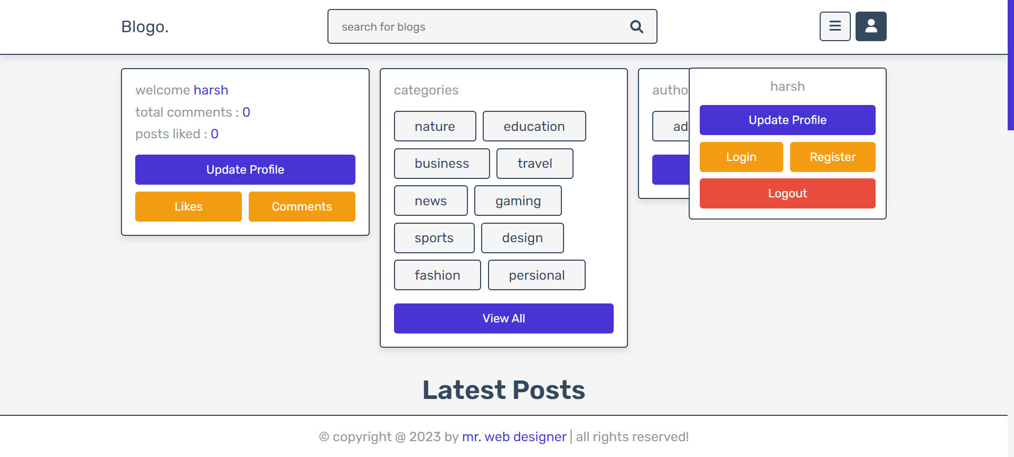

Good Read’s

%3CmxGraphModel%3E%3Croot%3E%3CmxCell%20id%3D%220%22%2F%3E%3CmxCell%20id%3D%221%22%20parent%3D%220%22%2F%3E%3CmxCell%20id%3D%222%22%20value%3D%22%26lt%3Bfont%20style%3D%26quot%3Bfont-size%3A%2036px%3B%26quot%3B%26gt%3B*%26lt%3B%2Ffont%26gt%3B%22%20style%3D%22text%3Bhtml%3D1%3BstrokeColor%3Dnone%3BfillColor%3Dnone%3Balign%3Dcenter%3BverticalAlign%3Dmiddle%3BwhiteSpace%3Dwrap%3Brounded%3D0%3B%22%20vertex%3D%221%22%20parent%3D%221%22%3E%3CmxGeometry%20x%3D%22960%22%20y%3D%22389%22%20width%3D%2260%22%20height%3D%2230%22%20as%3D%22geometry%22%2F%3E%3C%2FmxCell%3E%3C%2Froot%3E%3C%2FmxGraphModel%3E%3CmxGraphModel%3E%3Croot%3E%3CmxCell%20id%3D%220%22%2F%3E%3CmxCell%20id%3D%221%22%20parent%3D%220%22%2F%3E%3CmxCell%20id%3D%222%22%20value%3D%22%22%20style%3D%22endArrow%3Dnone%3Bhtml%3D1%3Brounded%3D0%3BentryX%3D0.5%3BentryY%3D1%3BentryDx%3D0%3BentryDy%3D0%3BexitX%3D0.5%3BexitY%3D0%3BexitDx%3D0%3BexitDy%3D0%3B%22%20edge%3D%221%22%20parent%3D%221%22%3E%3CmxGeometry%20width%3D%2250%22%20height%3D%2250%22%20relative%3D%221%22%20as%3D%22geometry%22%3E%3CmxPoint%20x%3D%22-151%22%20y%3D%22463%22%20as%3D%22sourcePoint%22%2F%3E%3CmxPoint%20x%3D%22-47.5%22%20y%3D%22240%22%20as%3D%22targetPoint%22%2F%3E%3C%2FmxGeometry%3E%3C%2FmxCell%3E%3C%2Froot%3E%3C%2FmxGraphModel%3E **Fig 6.16 User update profile & logout page**

* User Will Logout From the website .
* User has Viewed all post user will logout from website .
* User will update her profile.
* This is the website of User Logout Page.

## CONCLUSION

The Good Reads Is the website to reads different types of the blog user can search related any topic and user can view the blog , user can read the blog , If user interest into the blog user can like and comment , user will login into the over blog website from admin side I login into the admin panel then I check for user login, user likes counts,user comment, add some new blog,update blog , delete blog,add team,edit team and admin will logout from the website.

## FUTURE ENHANCMENT

This Good Reads website of different types of quotes my future scope is user get some new thing to read the blogs , my spacial scope is user know about the new tournaments,cricket,news etc.. , user will look that quotes and know about any related topic understand knew about new quotes we make website easy to use the user.

## REFERENCES

#### Description Websites

W3 schools **[www.w3schools.com](http://www.w3.com)**

Image **www.images.com**